Setting Up Periodic RSS Evaluations Using RSS Child Activities

To send an Evaluation to RSS attendees on a periodic basis (i.e.- once a year, bi-annually, quarterly, etc.), create a non-accredited RSS child activity with no CE credits designated, as an Evaluation placeholder and assign an Evaluation to the RSS child activity.
- In Activity Manager, search and select the Parent RSS activity from the Activity menu.
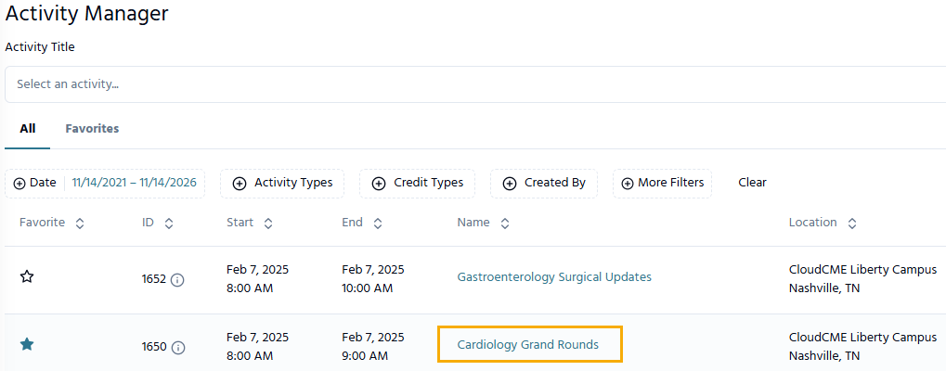
- Click on the Recurrence/Children tab on the Activity Editor screen.
Scroll to the Recurrence Management section and select the Add Child button.
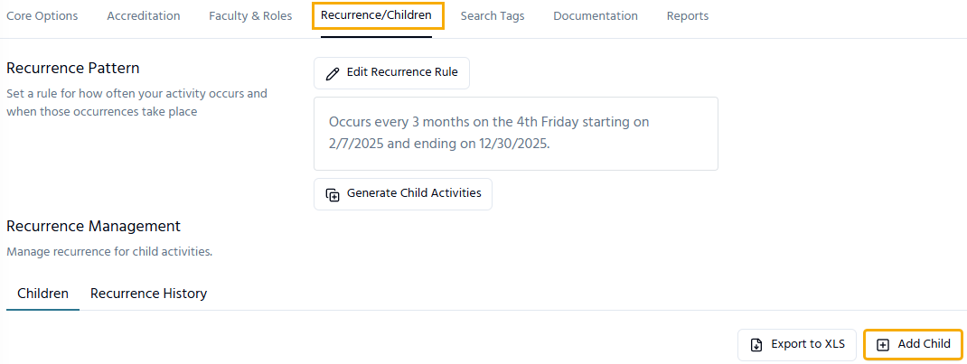
- Type the name of the child activity, select the Start and End Date, and click Create.
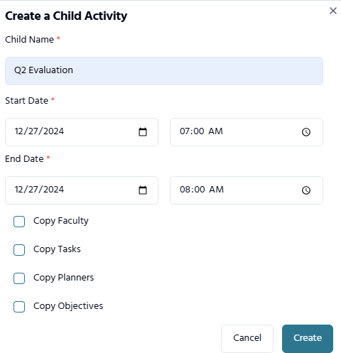
NOTE: Create an RSS Child evaluation placeholder activity for each evaluation (ex.- one for each quarter, two for bi-annual evaluations, etc.).

- Once the RSS child evaluation placeholder has been created, click the 3 dots at the end of the row and select View in Activity Editor.
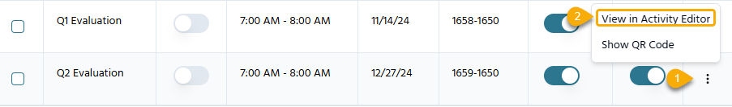
TIP: Clicking the name will also direct you to the Activity Editor.

- The newly created RSS child activity will open in the Activity Editor. Ensure that all information is correct on the Basic Information tab.
- Click the Types & Formats tab.
- For Is Accredited?, Select No from the drop-down menu.
- For Activity Type, select Non-Accredited – Regularly Scheduled Series from the drop-down menu.
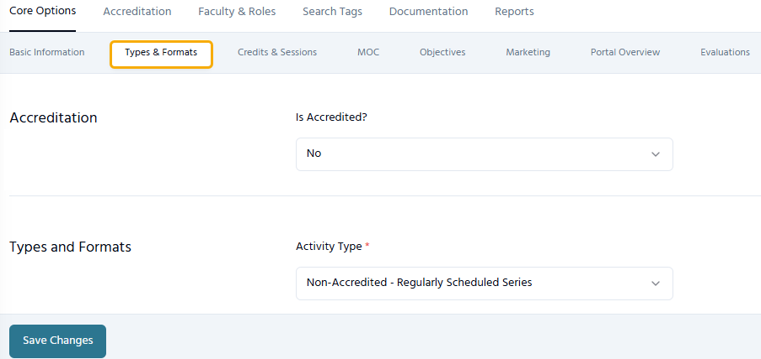

- Next, go to the Credits & Sessions tab in Activity Editor. In the Credits section, delete any accredited credit types (ex. - ACPE, ABPath MOC, etc.) by clicking the red X.
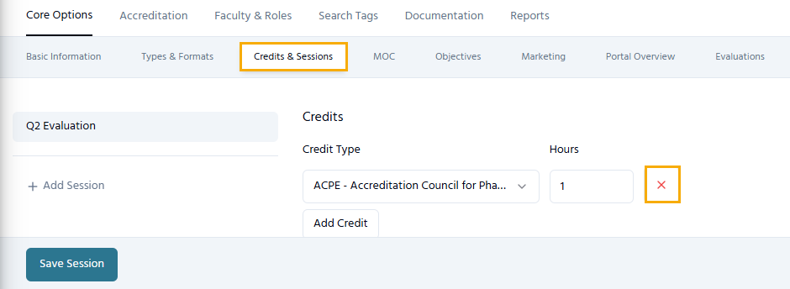
Click the Add Credit button.
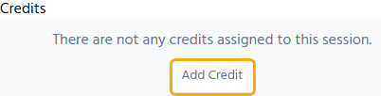
Check the Non-CME credit type and enter the amount of Non-CME credits to award (this can be set to zero). Then, click Save Session.
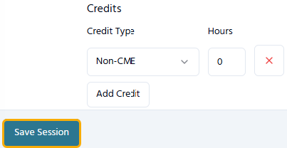
NOTE: If the Non-CME credit type does not display, an Administrator can add it to the Administration > Defaults screen on the Credit Types tab.

- From the Main Menu, go to Forms. In the Type column, find, duplicate and assign the Template Evaluation form that will be used for the RSS Child Evaluation Place Holder activity.
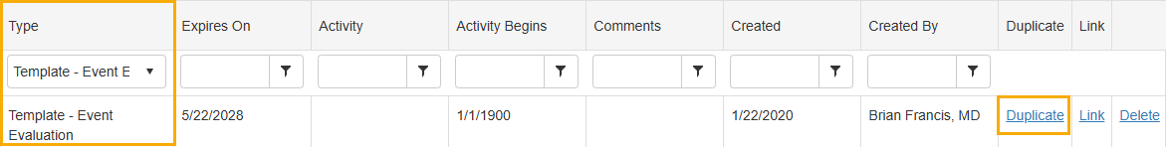

- Click the Reset button, and the duplicated form will display at the top of the table.
Click the Form Properties link in the Edit Form Properties column to edit the form.
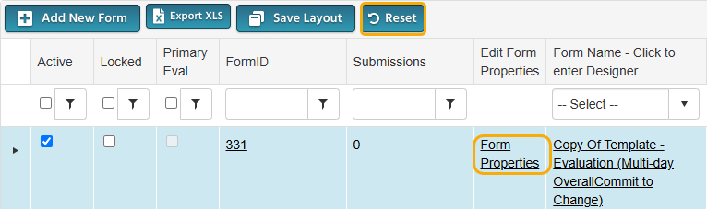
- In the Form Name field, rename the form to reflect the RSS child activity evaluation placeholder name.
In the Activity field, assign the form to the RSS child evaluation activity.
Then, click Update.
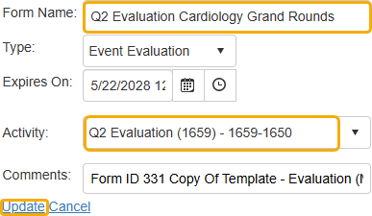
- Next, go to the Activities > Record Attendance screen.
Search and select the RSS child evaluation activity.
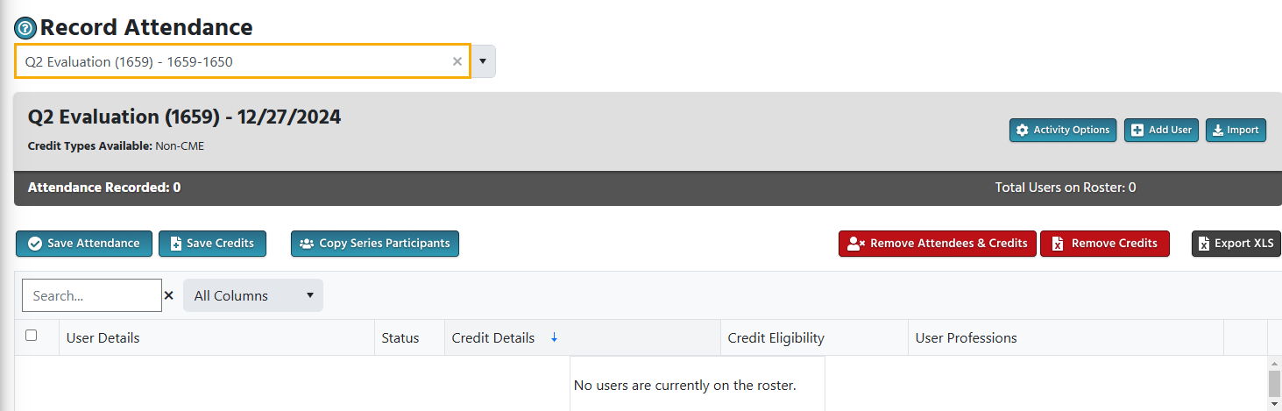
- Click on the “Copy Series Participants” button to copy the roster from the parent activity to the child activity.
The screen will display the activity attendance and all users who attended the RSS activity to date.
Click the Select All checkbox and then click Save Attendance.
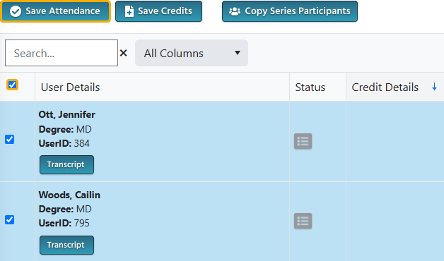
- The RSS child evaluation activity will display for the user in the Attendee Portal > My CE > Evaluations and Certificates section. The user will click on the Complete Evaluation button to complete the evaluation for the RSS activity.
